a. How much does peering cost?
There's no charge for creating the VPC peering connection itself. However, you are charged standard AWS data transfer rates for any data that flows across the peering connection. The pricing depends on the AWS regions the VPCs are in.
b. Can you peer with a virtual network in another account?
Yes, you absolutely can peer a VPC in your AWS account with a VPC in another AWS account. This is a common scenario for collaboration or centralized services.
c. Is peering transitive?
No, VPC peering is **not** transitive. If you have VPC A peered with VPC B, and VPC B peered with VPC C, VPC A and VPC C are **not** automatically peered. You would need to establish a direct peering connection between VPC A and VPC C if you want them to communicate.
d. Where is peering configured in the cloud platform?
VPC peering is configured within the **Amazon Virtual Private Cloud (VPC) service** in the AWS Management Console. You'll find the peering connection options under the "Peering Connections" section of the VPC dashboard.
e. What resources must already exist before peering can be established?
The primary resources that must exist are the **two Virtual Private Clouds (VPCs)** that you want to peer. Each VPC must have a unique CIDR block that does not overlap with the other VPC's CIDR block.
f. What are the basic steps to create the peering connection?
The basic steps involve:
1. Initiating the peering request: From one of the VPCs (the requester), you initiate a request to peer with the other VPC (the accepter). You'll need to provide the accepter VPC's ID and AWS account ID (if it's in a different account) and Region.
2. Accepting the peering request: The owner of the accepter VPC must then accept the peering request.
3. Updating route tables: Once the peering connection is active, you need to update the route tables in each VPC to direct traffic destined for the CIDR block of the peered VPC to the peering connection.
g. What significant limitations exist on the peering service for this platform?
Some significant limitations include:
No transitive peering: As mentioned before, peering is a one-to-one relationship and not transitive.
No overlapping CIDR blocks: The CIDR blocks of the peered VPCs must be unique and cannot overlap.
Security groups are not automatically shared: Security group rules in one VPC do not automatically apply to resources in the peered VPC. You need to explicitly configure security group rules to allow traffic to and from the peered VPC.
Limitations on the number of peering connections per VPC: There are limits on the number of peering connections a single VPC can have.
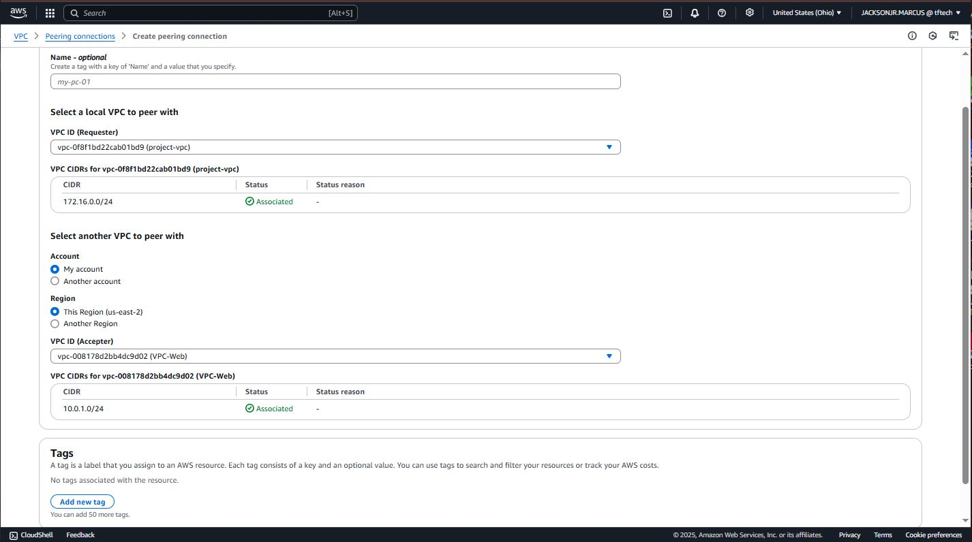
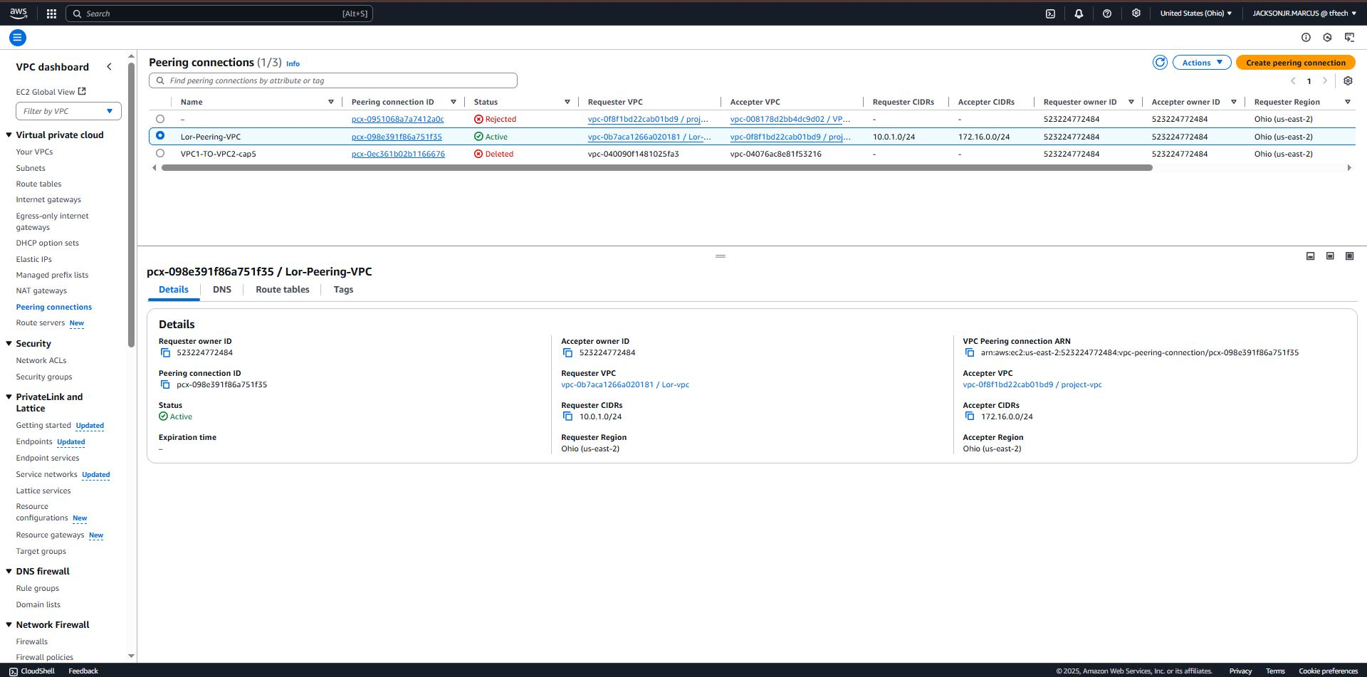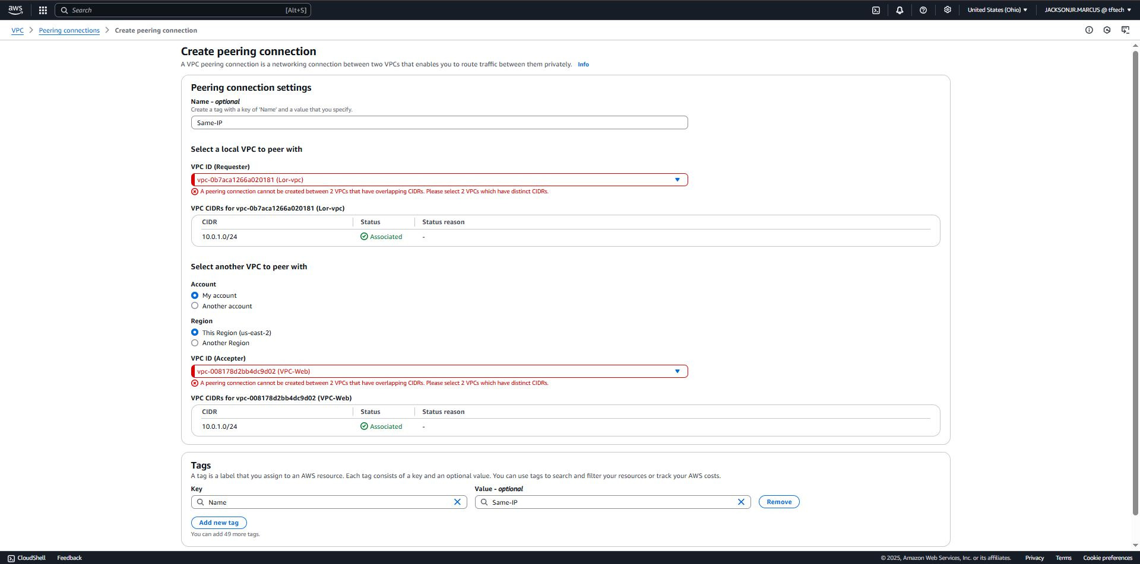

10.0.1.0/24
10.0.2.0/24
10.0.3.0/24
These blocks are within the private IP address range (10.0.0.0/8) and provide 256 addresses each, which is typical for a /24 network. They are distinct and won't cause any routing conflicts when you establish the peering connections.

